**System Design**

The Soybean Forecasting system will consist of a single user interface with three separate tabs containing relevant information for users to interpret their opinions on the soybean market. When visiting the page, the interface will default to a home page that consists of a quick mash-up of a few features: a snippet of relevant and recent soybean news, a small graph showing a price prediction model for a selected contract date, and a weather bar that allows the user view weather data for a specific location and date range. A general UI layout of the main page is shown below in Figure 1. Each section of the main page will have a header button or “double-click” action that will redirect the interface to the related tab designated for that feature. For example, double-clicking the relevant news section header will move the user from the main tab to the “News/Weather” tab.

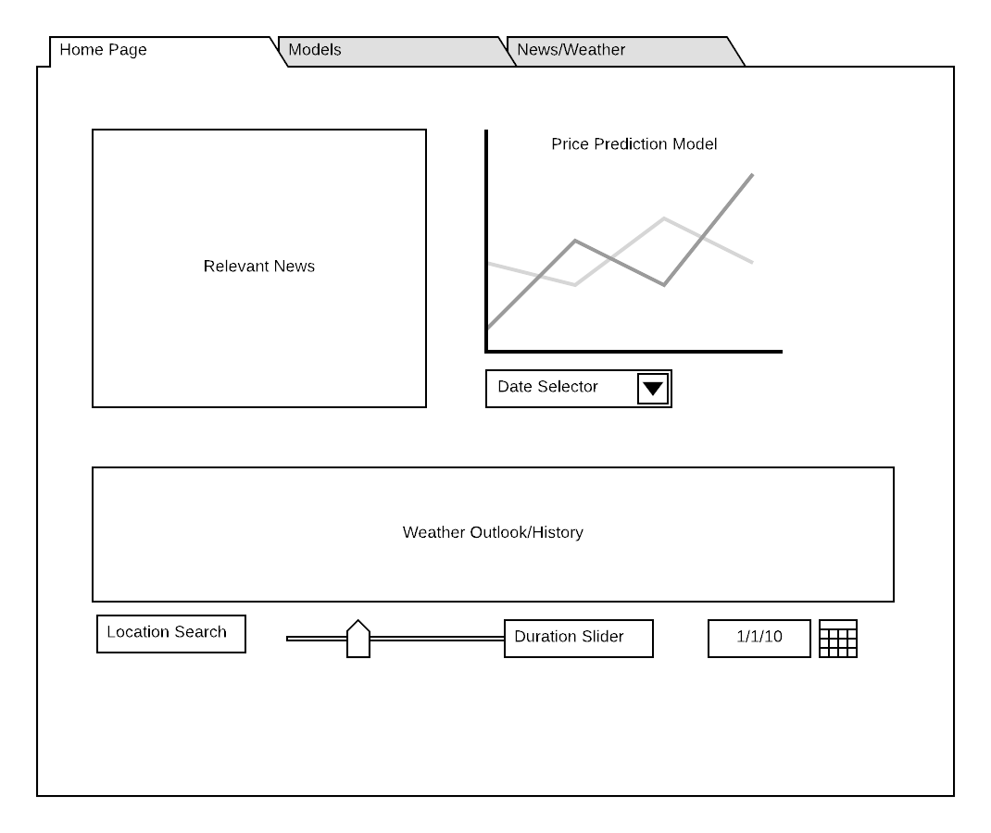

**Figure 1**

If the user clicks on the second tab named “Models” or double-clicks the header of the model section on the main page, a new page will be shown that is centered around models. Similar to the model section on the main page, a predictive model will be featured at the top of the layout. This model will have multiple input options allowing the user to view different contract dates, various model types, and select various secondary input options for the price model. Each change in input selections will trigger an update or refresh to the price model to account for the change. Below the price model section, a graphic section centered around possible predictive variables for soybean prices. These include various related data such as supply, import, export, and related product demand. Based on the related data category selected, a new time based or related input will appear to allow the user to further refine the graphics below. Figure 2 below shows a basic mock-up of this page.

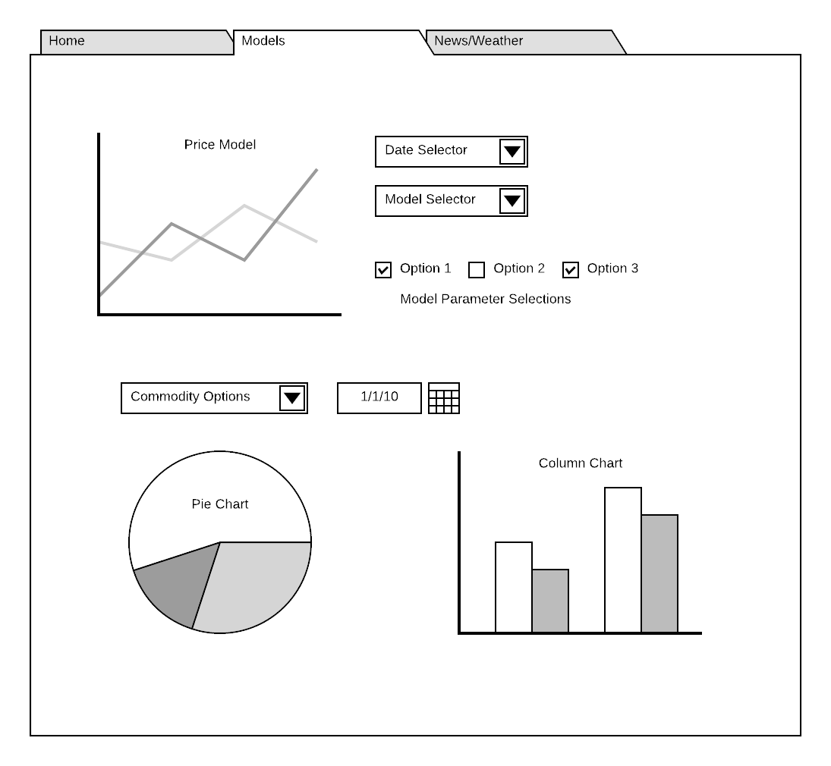

**Figure 2**

If the user clicks on the third tab named “News/Weather” or double-clicks the header of the news or weather section on the main page, a new tab will be shown that contains more information regarding news reports and weather trends. This page will have a similar layout to the main page with a top section focused on news feeds and the bottom section focused on weather information. The news feed section will have a larger space than the main page and contains a slider to allow the user to scroll for any of the relevant soybean articles. Next to the newsfeed, a basic graph showing the overall sentiment of all soybean articles will be shown. This sentiment analysis will show the positivity versus negativity of the news as well as keywords found throughout the article headers. The weather section of this page will be very similar to the main page with more space allowed. There is a location search input to direct the weather report to the area desired as well as a date input set up that varies when a forecast report starts and ends. Figure 3 below shows a basic mock-up of this page.

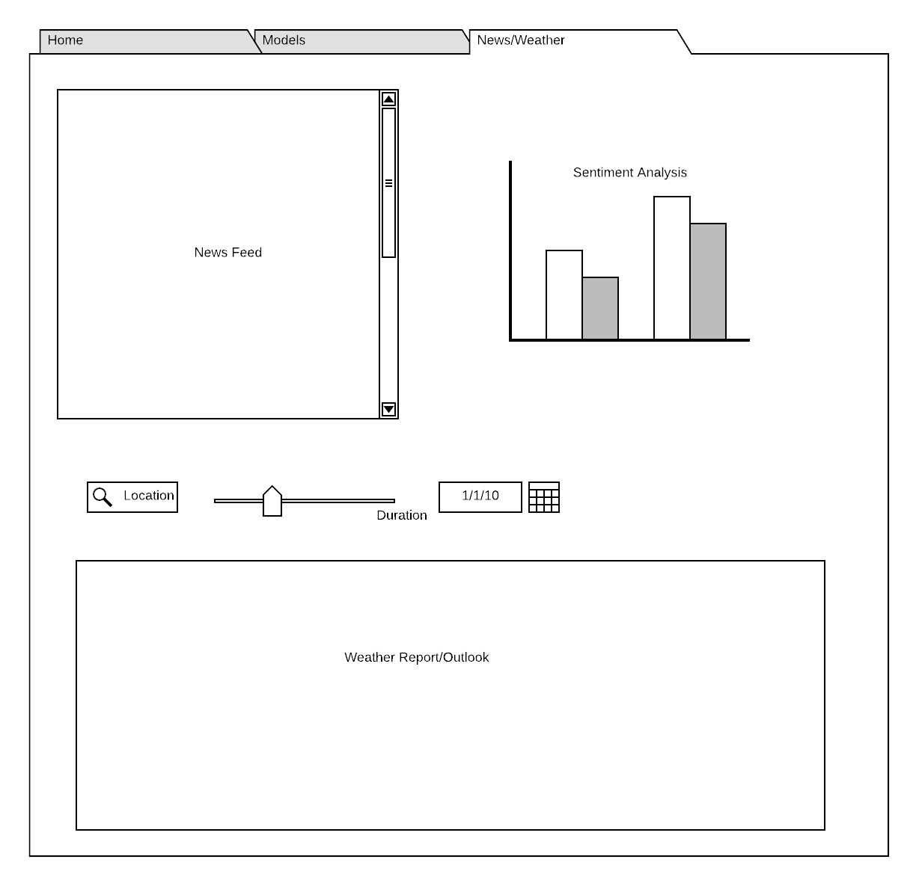

**Figure 3**

The flow of data through the system is shown below in Figure 4. The user interface is connected to a self-updating system. Every day, when the markets close, the system triggers a query for new information to be added to a database. If it is a weekday, soybean prices for the day are appended to the database as well as the general nationwide weather summary for the day. At the end of each month, when new monthly data is released, a query is made to append the supply, usage, and prices of soybeans and related soybean predictors to the database. Each time a user visits the product, a query is made to the database to grab the most recent information and subsequently is used to create the models and graphics shown above in Figures 1-3. Along with querying the database, each time a user visits the product, the system queries the current news regarding soybeans and puts the header and links into the news feed shown in Figures 1 and 3.

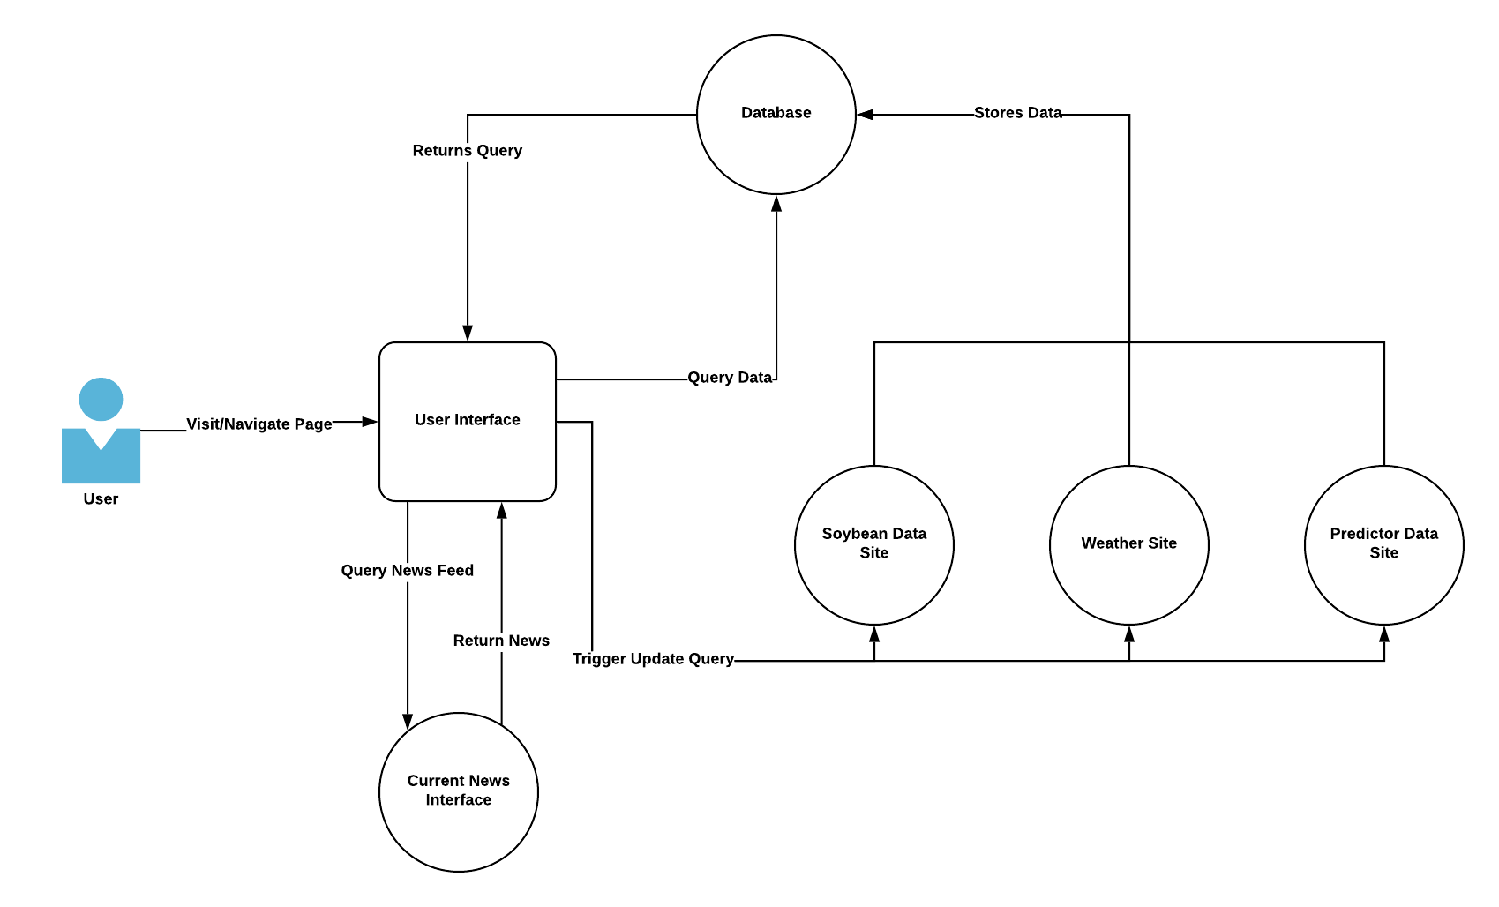

**Figure 4**

Figure 5, shown below, is a model for the database of this system. Since most of the data is a report and not a connected web, there are no links between the tables. The database stores the raw data that will be used for the model creation and graphics presented in Figures 1-3.

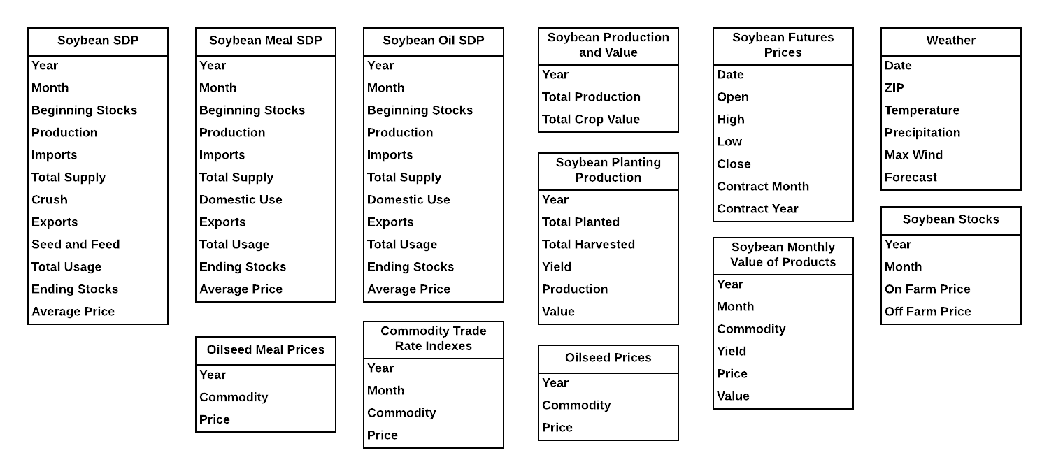

**Figure 5**